Columbia River Gorge National Scenic Area
Source Footprint Analysis Using CALPUFF and CMAQ Modeling Systems

Prepared by:

Jeremy Avise, Ying Xie, Jack Chen, and Brian Lamb
Laboratory for Atmospheric Research
Department of Civil & Environmental Engineering
Washington State University
Pullman, WA 99164-2910
(509) 335-5702
blamb@wsu.edu

Prepared for:

Department of Ecology
PO Box 47600
Olympia, WA

April 1, 2003
Table of Contents

Page

1. Introduction 2
2. Modeling Days 2
3. Footprint Modeling 3
3.1 Domain and Meteorology (MM5, CALMET) 3
3.2 CALPUFF Application 3
3.3 Overlay with Emissions 4
3.4 Source Footprints 6
4. CMAQ Modeling 7
5. Footprint Model Results 11
6. CMAQ Model Results 16
7. Summary 23
8. Recommendations 23
9. References 24
Appendix 25

1. Introduction

In response to the recommendation of the Columbia River Gorge Air Quality Project Technical Team an initial assessment of potential source regions which may impact the Columbia River Gorge National Scenic Area, was conducted by Washington State University (WSU). The assessment involved the application of a footprint modeling system, previously developed by WSU, to a selection of ten sample days in which high aerosol loadings were observed at both the Wishram and Mt. Zion IMPROVE sites (O’neill, 2002). The CALPUFF modeling system was used to determine the 24-hr fractional source contribution for areas upwind of each monitoring site. In addition, the Community Multi-Scale Air Quality (CMAQ) model was used to examine aerosol concentration patterns within the region and at the two sites for a two-day period in July, 1998.

The components of this source footprint modeling system are: 1) Mesoscale modeling of the regional wind field using the MM5 modeling system, 2) Application of the CALMET meteorological model (Scire et al., 1995) and inversion of the resulting wind field, 3) Use the inverted CALMET winds to drive the CALPUFF dispersion model (Scire et al., 1999) in a backward trajectory mode, and 4) Overlaying the resulting CALPUFF backpuff with the emissions inventory for the area.

The MM5 prognostic meteorological model provides detailed gridded hourly meteorological parameters to the CALMET diagnostic meteorological model. CALMET is then used to reformat the MM5 output into a usable form for CALPUFF. The CALMET wind fields are then inverted and applied to the CALPUFF model. By driving CALPUFF with the inverted winds we are essentially running CALPUFF in a reverse mode, where the resulting backpuff indicates the upwind source area affecting the downwind receptor due to transport and dispersion of the pollutant. Finally, the backpuff is overlaid with a gridded emissions inventory to create a detailed source footprint representing the fractional source contribution of each emission on the receptor concentrations.

2. Modeling Days

Modeling days were chosen from the September 1996 – October 1998 time period in which IMPROVE aerosol and extinction data were collected continuously at both the Wishram and Mt. Zion sites. Ten footprint modeling days were chosen on the criteria that both sites encountered aerosol concentrations within the upper 75th percentile for vision impairment. Simulations were completed for the following days:

September 10, 1997 November 12, 1997
September 24, 1997 December 10, 1997
October 15, 1997 July 8, 1998
October 22, 1997 July 22, 1998
November 5, 1997 July 29, 1998

The CMAQ model was applied for July 21-22, 1998. On July 22, 1998, aerosol concentrations within the upper 75th percentile occurred only at the Wishram site, but modeling results for both sites are presented in this report.

3. Footprint Modeling

3.1 Domain and Meteorology (MM5, CALMET)

Archived MM5 data were obtained from the University of Washington’s (UW) Pacific Northwest mesoscale forecast system (http://www.atmos.washington.edu/mm5rt/) for all but the final two modeling days (7/22/98, 7/29/98 were not available). The archived MM5 simulations were run using 3 nested domains with grid sizes of 36-km, 12-km, and 4-km centered around Seattle, WA. The 4-km domain did not encompass the Columbia River Gorge study region at that time, so the 12-km MM5 winds were used as input into the CALMET/CALPUFF system. Since the Columbia Gorge is a region of complex terrain, it was desirable to model the source footprints on a finer grid scale than 12-km. Therefore, CALMET was used to interpolate the 12-km MM5 winds to a 4-km grid by combining 4-km geophysical data with the 12-km MM5 winds. Although this method introduces no new meteorological data into the system, the 4-km wind field should be superior to the initial 12-km winds since the effects of terrain are incorporated at a finer resolution (4 km).

For the two days in which archived MM5 data were not available from UW, WSU simulated the historical meteorological conditions by applying MM5 to the region using similar 3 nested domains with grid sizes of 36-km, 12-km, and 4-km, which was later used in the CMAQ simulation. However, in this case, the 4-km grid was extended to encompass the entire Columbia Gorge region, so that CALMET was not needed to interpolate the winds to a finer scale. Instead, CALMET was applied to the 4-km wind fields in a pass-through mode, where no additional meteorological or geophysical data were introduced, to interpolate the winds to the CALPUFF domain. The final CALMET winds were then temporally and spatially inverted by reversing time and by reversing the direction of the uvw wind components. The inverted wind fields were then used to drive CALPUFF in a backward trajectory mode.

3.2 CALPUFF Application

The CALPUFF dispersion model was applied in reverse mode to simulate a 24-hr upwind probability source distribution for a receptor through puff dispersion theory along a backward trajectory. A source probability distribution was created for both the Wishram and Mt. Zion IMPROVE sites on each of the ten study days. Figure 1a shows a backward puff representing the upwind probability source distribution of an inert pollutant for the Wishram site on July 8, 1998, and Figure 1b shows the same backpuff for a first order reactive pollutant on the same day. Here, reverse chemistry was applied as the puff was advected along the backward trajectory to simulate production of the pollutant. This allows for the development of a more realistic probability source distribution that recognizes and takes into account the destruction of a pollutant as it is transported from source to receptor. It should be noted that the difference in magnitude of concentrations in Figure 1a and 1b does not affect study results because a normalized backpuff is used in the modeling process.

In the traditional forward mode, for a continuous source, a 24-hr CALPUFF simulation, represents the 24-hr concentration distribution of the pollutant. However, when run in reverse mode the model output represents the probability that a source location contributed to the impact of the receptor during the first hours of the simulation. Therefore, a longer model simulation considers more possible source locations. However, these additional source locations are assigned a smaller probability of contribution because of the further distance traveled and longer travel time required to impact the source. To create a 24-hr probability distribution, twenty four CALPUFF simulations, one simulation for every hour of the day, are required. Simulation times of 24-hr were chosen to ensure that all probable source locations were included. These simulations were then summed on a per hour basis and averaged over the domain to create the 24-hr probability distribution. The probability distributions were then overlaid with a gridded emission inventory to create the source footprint.

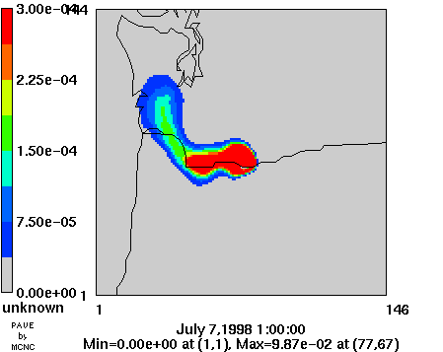
a
b

Figure 1. Backward puff depicting the upwind probability source distribution of
an (1a) inert pollutant and (1b) first order reactive pollutant for Wishram on July 8, 1998.
(revise figure to show better resolution within the red zones??
Would be revised
Figure 1. Backward puff depicting the upwind probability source distribution of
an (1a) inert pollutant and (1b) first order reactive pollutant for Wishram on July 8, 1998.

3.3 Overlay with Emissions

In order to develop a more meaningful source footprint, the CALPUFF probability source distribution is overlaid with the gridded emission inventory. To do this, a knowledge of travel time is necessary. This is because the concentration at a receptor at time t is the result of a combination of upwind emission sources from earlier times. Since plumes from multiple emission sources at varying distances from the receptor may impact the receptor at the same time, a modified CALPUFF code was used. This code includes a procedure to compute the average travel time (t_{avg}) of a plume, weighted by its concentration contribution, to be transported from grid point (i,j) to the receptor for each grid cell in the domain at every time t (O’Neill, 2002),

$t_{\text{avg}}(i,j,t)=\frac{\sum_{k=1}^{N}{T(i,j,t,k)∗C(i,j,t,k)}}{C_{T}(i,j,t)}$

Where,

$N=$Number of puffs emitted from the receptor from the beginning of the
simulation to time t.
$T(i,j,t,k)=$Travel time of puff k from the receptor to the grid location (i,j) at
time t.
$C(i,j,t,k)=$Concentration that puff k contributes to grid location (i,j), at
time t.
$C_{T}(i,j,t)=$Total concentration from all puffs at grid location (i,j), at time t.

Figure 2a and 2b show gridded hourly t_{avg} values of an inert and a first order reactive pollutant, respectively, for the Wishram receptor on July 8, 1998.

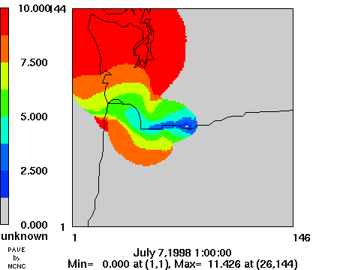
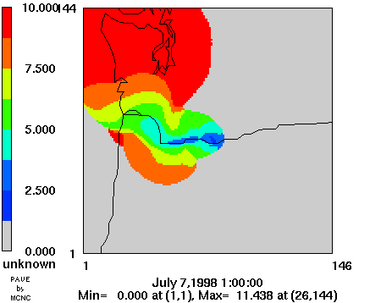
a
b

Figure 2. Average pollutant source travel times in relation to Wishram on July 8, 1998 for an (2a) inert pollutant and (2b) first order reactive pollutant.

Once the average travel time from grid cell (i,j) to the receptor is known, the corresponding emission that contributed to the receptor is the emission rate at time t-t_{avg}. The final result is a 2-dimensional travel time weighted emission inventory, where each grid point contains an emission that contributed to some extent to the concentration at the receptor. The fractional contribution of emissions, at a particular grid point, to the concentration recorded at the receptor can then be calculated by (O’Neill, 2002),

$$f(i,j,t)=\frac{E(i,j,t−t_{\text{avg}}(i,j,t))∗C(i,j,t)}{\sum_{i=1}^{R}{\sum_{j=1}^{C}{E(i,j,t−t_{\text{avg}}(i,j,t))∗C(i,j,t)}}}$$

Where,

$C,R=$Number of columns and rows in the domain.
$E(i,j,t−t_{\text{avg}}(i,j,t))=$Emission rate, from the emission inventory, contributing
to the receptor concentration at time t.
$C(i,j,t)=$Concentration (as an indicator of probability) from the backward
CALPUFF plume.

Emission Inventory (EI) files for 1996 were provided by the Washington State Department of Ecology and the Oregon Department of Environmental Quality for use in this study. Emissions were not adjusted to reflect 1997 values. All EI files were processed using the SMOKE emissions processor, and were allocated hourly by activity profiles. For example, weekday and weekend days use different allocation methods for different source categories so emissions will vary depending on the time of day and day of the week. A summary of average daily emissions over the entire domain for the ten study days is shown in Table 1. In addition, average daily emissions within each of several arbitrarily defined source areas: Puget Sound, Portland, Tri Cities, Yakima, and the Columbia Gorge, are given in Tables A1 – A5 of the appendix.

Table 1. Summary of emissions (metric tons per day)
summed over the entire model domain.
Model species | Point sources | Area sources | Mobile sources | Total emissions
VOC | 79.2 | 1363.5 | 717.8 | 2160.4
SO2 | 315.8 | 110.6 | 19.6 | 446.0
NOX | 185.1 | 695.0 | 705.7 | 1585.8
CO | 498.0 | 3885.9 | 7814.1 | 12197.9
NH3 | 10.9 | 28.8 | 12.5 | 52.2
PM10 | 53.7 | 232.2 | 23.2 | 309.1
PM2.5 | 38.0 | 215.0 | 20.4 | 273.4

3.4 Source Footprints

Two source footprints were generated for both the Wishram and Mt. Zion IMPROVE sites on each of the ten study days. The first footprint represents the fractional source contribution of an anthropogenic pollutant, using CO emissions as a surrogate for all anthropogenic emissions for the sites. The second footprint represents the fractional source contribution of a first order reactive pollutant, modeled as SO₂, for each site. Figure 3a, 3b shows the source footprints of an inert and reactive pollutant respectively, for the Wishram site on July 8, 1998.

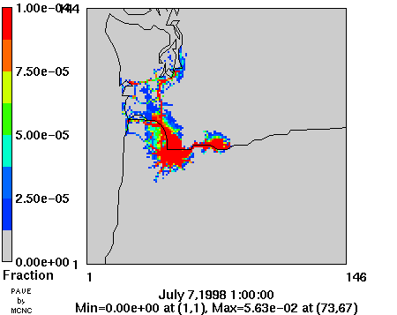
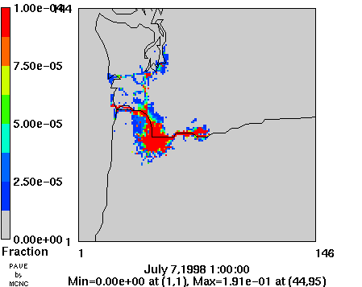
a
b

Figure 3. Fractional source contributions of a (3a) inert pollutant (3b) first order reactive pollutant on the receptor concentrations at Wishram on July 8, 1998.

4. CMAQ Modeling

In the CMAQ simulation, MM5 was used as the meteorology driver. Three one-way nested domains with grid sizes of 36-km, 12-km, and 4-km were developed with analysis nudging applied to the 36-km and 12-km girds. MM5 was run in nonhydrostatic mode with 37 vertical sigma layers and a horizontal domain of 112 x 112 grid cells in the innermost 4-km domain.

MCIP2 was used to generate 3-D and 2-D netCDF meteorology fields by processing the 4-km gridded output file from the MM5 run. Original PBL and radiation fields from MM5 were passed through MCIP2 without recalculation. Eighteen vertical layers were collapsed from the 37 MM5 layers with the surface layer held at 38 m. Horizontally, MCIP2 extracted a 99 X 99 4-km gridded domain directly from the MM5 4-km output file without further interpolation.

The CMAQ chemical transport model (CCTM) was run for a 48-hr period on July 21 – 22, 1998 with RADM2 photochemical mechanism, the Carter four-product isoprene oxidation mechanism, including aerosol module 3 and aqueous chemistry. Initial and boundary conditions were developed from observations and results provided by the Carmichael global modeling group (Carmichael, personal communication). The boundary conditions are summarized in Table 2. A two-day model spin-up was used to minimize any undesirable influence from model initial conditions. The PMx software (Jiang and Yin, 2001 and 2002) was used to convert the CMAQ mode outputs into PM2.5 size resolution. Details about CMAQ mapping of aerosol mass and extinction coefficient are shown in Table 3.

Table 2. Boundary concentrations with 10 vertical sigma levels used at
0.998, 0.992, 0.979, 0.955, 0.921, 0.878, 0.826, 0.734, 0.519, 0.149, and 0.000.
(note: ASEASª was used for the north, east, south boundary; ASEAS^{b} was used for the west boundary.)
CMAQ Species | Units | Concentration
O3 | ppb | 40 | 40 | 40 | 40 | 44 | 48 | 50 | 54 | 65 | 150
H2O2 | ppb | 1 | 1 | 0.9 | 0.7 | 0.5 | 0.4 | 0.4 | 0.3 | 0.1 | 0.003
NO | ppb | 0.02 | 0.02 | 0.02 | 0.01 | 0.01 | 0.015 | 0.015 | 0.010 | 0.006 | 0.04
NO2 | ppb | 0.1 | 0.1 | 0.1 | 0.1 | 0.08 | 0.08 | 0.08 | 0.05 | 0.04 | 0.3
NO3 | ppb | 0.1 | 0.1 | 0.07 | 0.05 | 0.02 | 0.02 | 0.015 | 0.008 | 0.005 | 0.005
N2O5 | ppb | 0.005 | 0.005 | 0.005 | 0.005 | 0.005 | 0.004 | 0.004 | 0.003 | 0.002 | 0.001
HNO3 | ppb | 0.15 | 0.1 | 0.1 | 0.1 | 0.1 | 0.1 | 0.1 | 0.1 | 0.1 | 0.1
SO2 | ppb | 0.05 | 0.05 | 0.05 | 0.05 | 0.05 | 0.05 | 0.04 | 0.04 | 0.01 | 0.003
SULF | ppb | 0.3 | 0.3 | 0.3 | 0.27 | 0.26 | 0.25 | 0.21 | 0.13 | 0.001 | 0.001
CO | ppb | 160 | 160 | 160 | 160 | 160 | 160 | 160 | 140 | 80 | 70
HCHO | ppb | 0.15 | 0.1 | 0.1 | 0.1 | 0.1 | 0.07 | 0.04 | 0.03 | 0.01 | 0.004
OL2 | ppb | 0.2 | 0.2 | 0.17 | 0.13 | 0.1 | 0.08 | 0.08 | 0.06 | 0.06 | 0.001
ISO | ppb | 0.005 | 0.005 | 0.005 | 0.005 | 0.004 | 0.003 | 0.003 | 0.002 | 0.001 | 0.00001
ALD | ppb | 2.5 | 2.5 | 2.5 | 2.5 | 2.5 | 2.5 | 2.5 | 2.5 | 2.5 | 2.5
KET | ppb | 0.8 | 0.8 | 0.8 | 0.8 | 0.8 | 0.8 | 0.8 | 0.8 | 0.8 | 0.8
HC5 | ppb | 2.7 | 2.7 | 2.7 | 2.7 | 2.7 | 2.7 | 2.7 | 2.7 | 2.7 | 2.7
HC8 | ppb | 0.5 | 0.5 | 0.5 | 0.5 | 0.5 | 0.5 | 0.5 | 0.5 | 0.5 | 0.5
TOL | ppb | 0.4 | 0.4 | 0.4 | 0.4 | 0.4 | 0.4 | 0.4 | 0.4 | 0.4 | 0.4
XYL | ppb | 0.5 | 0.5 | 0.5 | 0.5 | 0.5 | 0.5 | 0.5 | 0.5 | 0.5 | 0.5
OLT | ppb | 0.2 | 0.2 | 0.2 | 0.2 | 0.2 | 0.2 | 0.2 | 0.2 | 0.2 | 0.2
OLI | ppb | 0.4 | 0.4 | 0.4 | 0.4 | 0.4 | 0.4 | 0.4 | 0.4 | 0.4 | 0.4
ASO4J | μg m⁻³ | 0.648 | 0.648 | 0.648 | 0.648 | 0.648 | 0.648 | 0.648 | 0.648 | 0.648 | 0.648
ASO4I | μg m⁻³ | 0.292 | 0.292 | 0.292 | 0.292 | 0.292 | 0.292 | 0.292 | 0.292 | 0.292 | 0.292
ANH4J | μg m⁻³ | 0.114 | 0.114 | 0.114 | 0.114 | 0.114 | 0.114 | 0.114 | 0.114 | 0.114 | 0.114
ANH4I | μg m⁻³ | 0.018 | 0.018 | 0.018 | 0.018 | 0.018 | 0.018 | 0.018 | 0.018 | 0.018 | 0.018
ANO3J | μg m⁻³ | 0.063 | 0.063 | 0.063 | 0.063 | 0.063 | 0.063 | 0.063 | 0.063 | 0.063 | 0.063
Table 2 (Cont.)
CMAQ Species | Units | Concentration
ASEASª | μg m⁻³ | 0.000 | 0.000 | 0.000 | 0.000 | 0.000 | 0.000 | 0.000 | 0.000 | 0.000 | 0.000
ASEAS^{b} | μg m⁻³ | 20.000 | 10.000 | 0.000 | 0.000 | 0.000 | 0.000 | 0.000 | 0.000 | 0.000 | 0.000
AECJ | μg m⁻³ | 0.050 | 0.050 | 0.050 | 0.050 | 0.050 | 0.050 | 0.050 | 0.050 | 0.050 | 0.050
AH2OJ | μg m⁻³ | 0.510 | 0.510 | 0.510 | 0.510 | 0.510 | 0.510 | 0.510 | 0.510 | 0.510 | 0.510
NUMATKN | # m⁻³ | 3.50E+08 | 3.50E+08 | 3.50E+08 | 3.50E+08 | 3.50E+08 | 3.50E+08 | 3.50E+08 | 3.50E+08 | 3.50E+08 | 3.50E+08
NUMACC | # m⁻³ | 8.60E+07 | 8.60E+07 | 8.60E+07 | 8.60E+07 | 8.60E+07 | 8.60E+07 | 8.60E+07 | 8.60E+07 | 8.60E+07 | 8.60E+07
NUMCOR | # m⁻³ | 5.60E+06 | 5.60E+06 | 5.60E+06 | 5.60E+06 | 5.60E+06 | 5.60E+06 | 5.60E+06 | 5.60E+06 | 5.60E+06 | 5.60E+06

Table 3. CMAQ Species Mapping (shown as reconstructed).
Compound | Species Mapping | Visibility Mapping
SO4 | 1.37*(ASO4J + ASO4I) | 3*f(RH)*SO4
NO3 | 1.29*(ANO3J + ANO3I) | 3*f(RH)*NO3
OC | AORGAJ+AORGAI+AORGPAJ+  AORGPAI+AORGBJ+AORGBI | 4*OC
EC | AECJ+AECI | 10*EC
SOIL | A25I + A25J | 1*SOIL
CM | ACORS + ASEAS + ASOIL | 0.6*CM
PM2.5 | Calculated by PMx software
Air Molecules |  | 10
Total fine mass | SO4+NO3+OC+EC+SOIL
Total mass | SO4+NO3+OC+EC+SOIL+CM
Fine Bext |  | 10 + 3*f(RH)*(SO4 + NO3) + 4*OC + 10*EC + SOIL
Total Bext |  | 10 + 3*f(RH)*(SO4 + NO3) + 4*OC + 10*EC + SOIL + 0.6*CM
Deciview |  | 10*LN(Total Bext/10)

5. Footprint Model Results

Results for all days were summarized by summing the weighted emission footprint within each of several arbitrarily defined source areas: Puget Sound, Portland, Tri Cities, Yakima, and the Columbia Gorge (Figure 4). These results are shown in Figures 5 and 6, and in Tables 4 and 5 (footprints for all study days are located in the appendix). Model results showed a wide range of spatial variability in source footprints for both the Wishram and Mt. Zion sites. The majority of source probabilities were confined to the Portland and Columbia Gorge regions, and to the portion of the grid not included in the five source areas. In most cases, source areas were similar between the Wishram and Mt. Zion sites. However, the relative importance of each source area was significantly different between the two sites in many cases. Incorporating reverse chemistry into the footprint model had the effect of reducing the importance of emissions within the Columbia Gorge region, and placing more emphasis on those outside of the region. In all but one case, for both the Wishram and Mt. Zion sites, reverse chemistry increased the probability of a source outside the sampling areas contributing more heavily to the pollutant concentration at the two sites. In approximately half the cases, reverse chemistry also altered the importance of sources within Portland. Of these cases, approximately half resulted in an increased importance and half resulted in a decrease of importance.

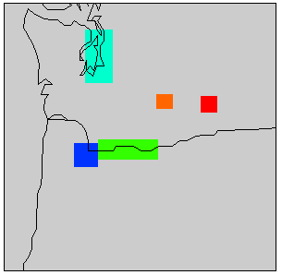
Puget Sound
Yakima
Tri Cities
Columbia Gorge
Portland

Figure 4. Source areas used to summarize weighted emission
footprint.

Figure 5. Probable source contribution areas as a fraction of the total observed fine mass for the Wishram IMPROVE site, where CO refers to an inert pollutant, and SO₂ refers to a first order reactive pollutant (note: fine mass data was not available for 971210 so a concentration of 10 μg m⁻³ was assumed).

Figure 6. Probable source contribution areas as a fraction of the total observed fine mass for the Mt. Zion IMPROVE site, where CO refers to an inert pollutant, and SO₂ refers to a first order reactive pollutant (note: fine mass data was not available for 971210, 980722, and 980729 so a concentration of 10 g m⁻³ was assumed).
Day |  | Probable source area contribution to total observed fine mass (μg m⁻³)
 |  | Portland | Puget  Sound | Columbia  Gorge | Yakima | Tri Cities | Rest  Of Grid
970910 | CO | 3.053 | 0.010 | 7.729 | 0.052 | 0.000 | 0.917
970910 | SO2 | 3.642 | 0.010 | 5.678 | 0.013 | 0.002 | 2.415
970924 | CO | 0.000 | 0.000 | 14.829 | 0.000 | 0.081 | 3.560
970924 | SO2 | 3.642 | 0.010 | 5.678 | 0.013 | 0.002 | 9.125
971015 | CO | 0.121 | 0.000 | 7.484 | 0.069 | 0.006 | 0.911
971015 | SO2 | 0.083 | 0.000 | 6.569 | 0.045 | 0.097 | 1.796
971022 | CO | 4.518 | 0.000 | 5.180 | 0.001 | 0.000 | 1.401
971022 | SO2 | 4.652 | 0.001 | 2.564 | 0.001 | 0.000 | 3.882
971105 | CO | 0.000 | 0.000 | 11.869 | 0.126 | 0.006 | 0.949
971105 | SO2 | 0.000 | 0.000 | 10.290 | 0.103 | 0.351 | 2.206
971112 | CO | 0.000 | 0.000 | 11.683 | 0.885 | 0.000 | 1.092
971112 | SO2 | 0.000 | 0.000 | 9.721 | 0.214 | 0.027 | 3.698
971210 | CO | 0.207 | 0.000 | 8.822 | 0.000 | 0.000 | 0.971
971210 | SO2 | 0.257 | 0.000 | 8.627 | 0.000 | 0.000 | 1.116
980708 | CO | 3.818 | 0.048 | 4.528 | 0.000 | 0.000 | 1.087
980708 | SO2 | 3.453 | 0.035 | 2.483 | 0.000 | 0.000 | 3.509
980722 | CO | 2.486 | 0.563 | 9.254 | 0.000 | 0.000 | 1.558
980722 | SO2 | 1.674 | 0.670 | 4.423 | 0.000 | 0.000 | 7.093
980729 | CO | 3.680 | 0.349 | 7.240 | 0.000 | 0.000 | 1.812
980729 | SO2 | 3.069 | 0.273 | 3.802 | 0.000 | 0.000 | 5.936

Table 4. Probable source area contribution to the total observed fine mass concentration at the Wishram IMPROVE site receptor, where CO refers to an inert pollutant, and SO₂ refers to a first order reactive pollutant (note: fine mass data was not available for 971210 so a concentration of 10 μg m⁻³ was assumed).

Table 5. Probable source area contribution to the total observed fine mass concentration at the Mt. Zion IMPROVE site receptor, where CO refers to an inert pollutant, and SO₂ refers to a first order reactive pollutant (note: fine mass data was not available for 971210, 980722, and 980729 so a concentration
Day |  | Probable source area contribution to total observed fine mass (μg m⁻³)
 |  | Portland | Puget  Sound | Columbia  Gorge | Yakima | Tri Cities | Rest  Of Grid
970910 | CO | 3.728 | 0.000 | 5.797 | 0.003 | 0.000 | 2.282
970910 | SO2 | 5.459 | 0.000 | 3.456 | 0.002 | 0.002 | 2.892
970924 | CO | 0.000 | 0.000 | 14.371 | 0.006 | 0.043 | 3.100
970924 | SO2 | 0.000 | 0.000 | 9.128 | 0.003 | 0.353 | 8.037
971015 | CO | 0.134 | 0.000 | 7.632 | 0.000 | 0.000 | 2.555
971015 | SO2 | 0.156 | 0.000 | 5.808 | 0.000 | 0.000 | 4.355
971022 | CO | 5.640 | 0.000 | 3.931 | 0.013 | 0.000 | 7.695
971022 | SO2 | 7.149 | 0.000 | 2.533 | 0.009 | 0.001 | 7.589
971105 | CO | 0.003 | 0.000 | 5.929 | 0.000 | 0.000 | 5.129
971105 | SO2 | 0.003 | 0.000 | 2.930 | 0.000 | 0.000 | 8.127
971112 | CO | 0.000 | 0.000 | 8.539 | 0.198 | 0.000 | 1.073
971112 | SO2 | 0.000 | 0.000 | 6.088 | 0.093 | 0.038 | 3.590
971210 | CO | 0.080 | 0.000 | 2.177 | 0.000 | 0.000 | 7.743
971210 | SO2 | 0.010 | 0.000 | 0.914 | 0.000 | 0.000 | 9.076
980708 | CO | 2.399 | 0.040 | 0.899 | 0.000 | 0.000 | 6.642
980708 | SO2 | 1.635 | 0.005 | 0.637 | 0.000 | 0.000 | 7.703
980722 | CO | 2.667 | 0.364 | 1.976 | 0.000 | 0.000 | 4.992
980722 | SO2 | 1.734 | 0.177 | 0.847 | 0.000 | 0.000 | 7.242
980729 | CO | 2.373 | 0.007 | 3.447 | 0.000 | 0.000 | 4.173
980729 | SO2 | 1.293 | 0.002 | 1.539 | 0.000 | 0.000 | 7.166
of 10 μg m⁻³ was assumed).

6. CMAQ Model Results

MM5 simulation of surface wind patterns and temperature contours are shown in Figure 7 and 8, respectively. Meteorological conditions during the July 21-22, 1998 period were generally fair with light to moderate winds. Within the Columbia River Gorge, winds were generally from the west during the day. Surface temperatures were higher east of the Cascades, which was consistent with the westerly flow through the gorge.

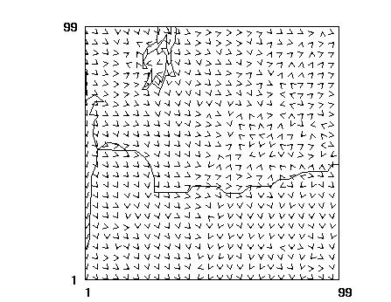
Figure 7. Surface wind patterns from MM5 for July 22,
1998 at 4:00 pm PDT.

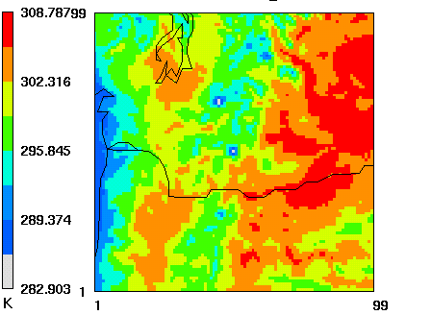

Figure 8. Surface temperature contours from MM5
for July 22, 1998 at 4:00 pm PDT.

Results from the CMAQ simulations are shown in Figure 9 in terms of surface layer PM2.5 concentration contours for July 22, 1998 at 5:00 PDT when the maximum domain averaged concentration occurred. Visibility contours in terms of deciview for the same hour are shown in Figure 10. Note that deciview is defined as: 10*LN(Total Bext/10), where Bext is the extinction coefficient.

These results show that high PM2.5 levels mainly occurred in Portland, along the west slope of the Cascades, and within the Seattle region. The corresponding visibility spatial pattern generally followed PM2.5 pattern with the highest impairment occurring within the Portland and Seattle regions. During the early morning hours, PM2.5 in the Columbia River Gorge region was approximately 20 μg m⁻³ with visibility parameter equal to approximately 20 deciviews.

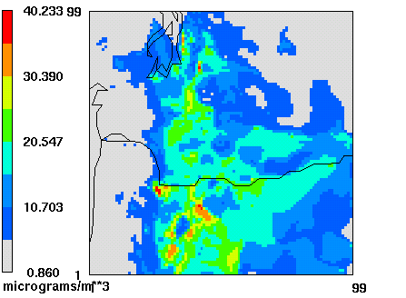

Figure 9. Surface layer PM2.5 concentrations estimated
with CMAQ for July 22, 1998 at 5:00 am PDT.

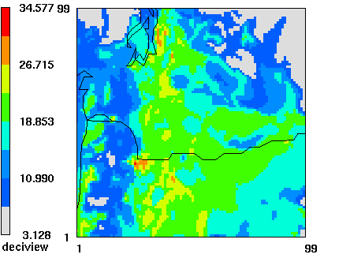

Figure 10. Visibility in terms of deciview estimated with CMAQ
for July 22, 1998 at 5:00 am PDT.

The diurnal patterns of PM2.5 and the individual aerosols that contribute to it are shown in Figure 11 and Figure 12 for the Wishram and Mt. Zion sites, respectively. Comparisons of CMAQ modeling results with IMPROVE site observations for aerosol concentrations, total PM2.5 budget, aerosol light extinction coefficient, and visibility impairment budget are given in Tables 6, 7, 8, and 9. Except for PM2.5 observations, which are based upon direct measurements, all data in the tables have been reconstructed as previously described in Table 3. Comparisons of contributions of different aerosol species to total PM2.5 concentration and visibility impairment are shown in Figure 13 and 14, respectively. CMAQ modeling results are averaged for the same 24-hr period to be consistent with the IMPROVE data.

The general diurnal patterns are similar for the two sites. However, variations of PM2.5 and organic carbon appeared to be more irregular at Mt.Zion. Organic carbon was the greatest component of all species, which contributed up to 14 μg m⁻³ to the total PM2.5 concentration. The PM2.5 pattern agreed well with the organic carbon pattern, both of which tended to increase during the night and decrease during the day. Sulfate also appeared to have higher concentration at nighttime, which peaked at Mt. Zion a few hours earlier than Wishram. Sulfate contributed up to 8 μg m⁻³ to the total PM2.5.

Model results show that the ratio of organic carbon to total PM2.5 varied from 0.38 to 0.60 with a 30 to 50% share in the total visibility extinction budget. Sulfate/PM2.5 ratio varied from 0.15 to 0.30 with sulfate accounting for about 20% of the visibility impairment. Nitrate contributed little to both total PM2.5 and visibility extinction budget (< 5%). Elemental carbon accounted for 6 to 10% of total PM2.5 and 15 to 20% of the visibility extinction budget. Soil took up to 12% of total PM2.5, but its contribution to visibility was less than 5%. In observation, coarse mass contributed about 10% to light extinction at Wishram, however in the CMAQ simulation it accounted for less than 2%.

Statistical results showed that the model performed well for PM2.5 and extinction coefficient with normalized bias less than 10%. The model under-predicted sulfate, while over-predicted organic carbon at both sites. At Wishram, both nitrate and coarse mass were severely under-predicted. At Mt. Zion, neither nitrate nor coarse mass data was available for that day. Discrepancies were present for both soil and elemental carbon with the model under-predicting at Wishram and over-predicting at Mt. Zion.
Figure 11. Concentration of PM2.5, SO4, NO3, EC, OC, Soil, and CM for July 21 to 22, 1998 at Wishram.

Figure 12. Concentration of PM2.5, SO4, NO3, EC, OC, Soil, and CM for July 21 to 22, 1998 at Mt. Zion.

Table 6. Comparisons of the CMAQ predictions with observations for PM2.5 concentration, reconstructed aerosol mass and visibility, and total PM2.5 budget at Wishram for July 22, 1998 (note: “--” means no data available).
Wishram | Concentration (μg m⁻³) |  |  |  |  |  |  | Total fine mass  (μg m⁻³) | Total mass  (μg m⁻³) | Total bext  (M m⁻¹) | Deciview
Wishram | PM2.5 | Sulfate | Nitrate | Org Carb | Soil | Elem Carb | CM
Observation | 13.86 | 4.14 | 0.47 | 5.31 | 1.65 | 0.87 | 10.92 | 12.44 | 23.35 | 65.40 | 18.78
Prediction | 13.070 | 2.702 | 0.010 | 7.814 | 0.402 | 0.782 | 0.601 | 11.711 | 12.312 | 60.01 | 17.92
Normalized  Bias | -5.7% | -34.8% | -97.8% | 47.3% | -75.6% | -10.5% | -94.5% | -5.8% | -47.3% | -8.2% | -4.6%
 | Ratio to total PM2.5
Observation |  | 0.299 | 0.034 | 0.383 | 0.119 | 0.063
Prediction |  | 0.207 | 0.001 | 0.598 | 0.031 | 0.060

Table 7. Comparisons of the CMAQ predictions with observations for PM2.5 concentration, reconstructed aerosol mass and visibility, and total PM2.5 budget at Mt. Zion for July 22, 1998 (note: “--” means no data available).
Mt. Zion | Concentration (μg m⁻³) |  |  |  |  |  |  | Total fine mass  (μg m⁻³) | Total mass  (μg m⁻³) | Total  bext  (M m⁻¹) | Deciview
Mt. Zion | PM2.5 | Sulfate | Nitrate | Org Carb | Soil | Elem Carb | CM
Observation | 13.46 | 4.32 | -- | 5.63 | 0.83 | 0.94 | -- | 11.72 | -- | -- | --
Prediction | 14.140 | 2.130 | 0.065 | 7.145 | 0.957 | 1.359 | 1.762 | 11.656 | 13.418 | 65.38 | 18.78
Normalized  Bias | 5.05% | -50.70% | -- | 26.86% | 15.81% | 44.82% | -- | -0.53% | -- | -- | --
 | Ratio to total PM2.5
Observation |  | 0.321 | -- | 0.418 | 0.061 | 0.070
Prediction |  | 0.151 | 0.005 | 0.505 | 0.068 | 0.096

Table 8. Comparisons of CMAQ predictions with observations for reconstructed particle extinction and aerosol light extinction budget at Wishram for July 22, 1998 (note: “--” means no data available).
Wishram | Light extinction (Mm⁻¹) |  |  |  |  |  |  |  | Total | Fine
Wishram | bray | Sulfate | Nitrate | Org Carb | Soil | Elem Carb | CM | f(rh) | bext | bext | Deciview
Observation | 10 | 15.50 | 1.74 | 21.22 | 1.65 | 8.74 | 6.55 | 1.25 | 65.40 | 58.85 | 18.78
Prediction | 10 | 10.13 | 0.04 | 31.26 | 0.40 | 7.82 | 0.36 | 1.25 | 60.01 | 59.65 | 17.92
 | Percent of Total bext
Observation | 15.3% | 23.7% | 2.7% | 32.4% | 2.5% | 13.4% | 10.0% |  |  | 90.0%
Prediction | 16.7% | 16.9% | 0.1% | 52.1% | 0.7% | 13.0% | 0.6% |  |  | 99.4%

Table 9. Comparisons of CMAQ predictions with observations for reconstructed particle extinction and aerosol light extinction budget at Mt. Zion for July 22, 1998 (note: “--” means no data available).
Mt. Zion |  | Light extinction (Mm⁻¹) |  |  |  |  |  |  | Total | Fine
Mt. Zion | bray | Sulfate | Nitrate | Org Carb | Soil | Elem Carb | CM | f(rh) | bext | bext | Deciview
Observation | 10 | 21.99 | -- | 22.53 | 0.83 | 9.38 | -- | 1.70 | -- | -- | --
Prediction | 10 | 10.86 | 0.33 | 28.58 | 0.96 | 13.59 | 1.06 | 1.70 | 65.38 | 64.32 | 18.78
 | Percent of Total bext
Observation | -- | -- | -- | -- | -- | -- | -- |  |  | --
Prediction | 15.3% | 16.6% | 0.5% | 43.7% | 1.5% | 20.8% | 1.6% |  |  | 98.4%

Figure 13. Comparisons of the CMAQ predictions with observations for contributions of aerosol species to total PM2.5 concentration at Wishram and Mt. Zion for July 22, 1998.

Figure 14. Comparisons of the CMAQ predictions with observations for contributions of aerosol species to light extinction budget at Wishram and Mt. Zion for July 22, 1998.
CMAQ was also used to simulate ozone formation within the domain for this 2-day period. Ozone domain contours are shown in Figure 15 and 16, respectively, for July 21 and 22, 1998 at 4pm PDT when the maximum domain averaged ozone concentration occurred for each day. CMAQ predicted elevated ozone concentrations for both days with the highest level occurring in the late afternoon in the Portland region. For the Columbia River Gorge area, ozone concentrations were approximately 60 to 90 ppb for the daytime high and 25 to 40 ppb for the nighttime low.

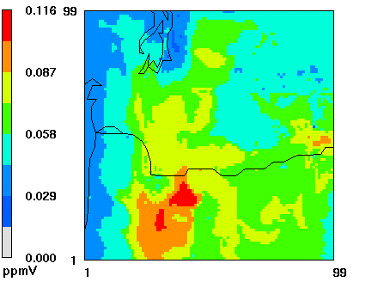

Figure 15. Surface layer ozone concentrations estimated
with CMAQ for July 21, 1998 at 4:00 pm PDT.

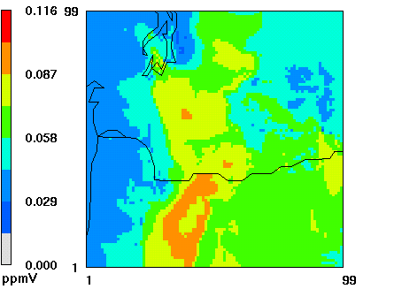

Figure 16. Surface layer ozone concentrations estimated
with CMAQ for July 22, 1998 at 4:00 pm PDT.

7. Summary

An assessment of potential source regions which may impact the Columbia River Gorge National Scenic Area was conducted on a set of ten study days between September 1997 and July 1998 for both the Wishram and Mt. Zion IMPROVE sites. The assessment involved the MM5/CALMET/CALPUFF modeling system applied in backward trajectory mode to develop an upwind probability source distribution. The probability source distribution was then overlaid with gridded emission inventory data to create a source footprint which defines the 24-hr fractional source contribution area on pollutant concentrations for the two IMPROVE sites. Two footprints were defined for each site on each modeling day, where one footprint is that of an inert pollutant and the other is for a pollutant undergoing first order transformation. Emission inventories of CO and SO₂ were used as surrogates for the inert and chemically reactive cases, respectively.

It was shown that chemistry effects play an important role in defining the footprint and results in increasing the importance of emissions further from the receptor. It was also shown that the Portland region can be a significant source of pollutants into the Columbia River Gorge, but that the Puget Sound, Yakima, and Tri Cities areas are either significantly far away or are too small of a source area to contribute to the pollutant concentrations at the Wishram and Mt. Zion IMPROVE sites.

July 21-22, 1998 was selected for a CMAQ modeling run to provide model estimates of primary and secondary particulate concentrations and prevailing visibility. Model results show that for both fine mass budget and visibility impairment budget, organic carbon is the greatest contributor, followed by sulfate. Spatially, the highest PM2.5 concentrations and visibility impairment occurred in Portland, along the west slope of the Cascades, and within the Seattle region. At both sites, the PM2.5 temporal pattern closely matches the variations in organic carbon concentrations, which increase during the night and decrease during the day. Statistical data show that CMAQ performed best for predicting PM2.5 and extinction coefficient, while over-predicting organic carbon and under-predicting sulfate and nitrate.

8. Recommendations

These modeling results suggest several areas of improvement for future footprint studies within the Columbia Gorge.

- The inclusion of a more advanced chemical mechanism for each chemical species contributing to the aerosol concentration at the IMPROVE site would be beneficial for developing a more realistic source footprint for each species.

- Analysis on a more extensive group of source areas and on a finer scale would improve our ability to determine the most probable source areas.

- Further chemical transport modeling including longer modeling period and on a finer scale would help to further understand the particle formation and visibility impairment in the scenic area.

9. References

Carmichael, G., 2003. Personal communication regarding initial and boundary conditions for CMAQ modeling.

Dudhia, J., G. A. Grell, and D. R. Stauffer, 1994. A description of the Fifth-Generation Penn State/NCAR Mesoscale Model (MM5). NCAR Technical Note NCAR/tN-398+STR.

Jiang, W., D. Yin, 2001. Development and application of the PMx software package for converting CMAQ modal particulate matter results into size-resolved quantities. Program of Energy Research and Development, Natural Resources Canada. PET-1497-01S.

Jiang, W., D. Yin, 2002. Mathematical formulation and consideration for converting CMAQ modal particulate matter results into size-resolved quantities. American Meteorology Society Fourth Conference on Atmospheric Chemistry: Urban, Regional, and Global-Scale Impacts of Air Pollutants, PP. 7-14.

O’Neill, S. M., 2002. Modeling ozone and aerosol formation and transport in the pacific northwest and calculating fractional source contributions to downwind receptors. Doctorate Thesis, Department of Civil & Environmental Engineering, Washington State University, 160 pp.

Scire, J. S., E. M. Insley, R. J. Yamartino, and M. E. Fernau, 1995. A user’s guide for the CALMET meteorological model. Earth Tech Inc., 193 pp.

Scire, J. S., D. G. Strimaitis, and R. J. Yamartino, 1999. A user’s guide for the CALPUFF dispersion model (version 5.0). Earth Tech Inc., 462 pp.

Appendix

Table A1. Summary of emissions (metric tons per day) summed over the
Puget Sound source region.
Model species | Point sources | Area sources | Mobile sources | Total emissions
VOC | 16.7 | 403.2 | 2347.1 | 3616.0
SO2 | 13.4 | 25.9 | 6.1 | 45.3
NOX | 35.1 | 170.2 | 221.8 | 427.1
CO | 64.9 | 1204.0 | 2347.1 | 3616.0
NH3 | 1.8 | 2.0 | 4.1 | 8.0
PM10 | 6.0 | 76.0 | 6.7 | 88.7
PM2.5 | 3.5 | 70.7 | 5.8 | 80.0

Table A2. Summary of emissions (metric tons per day) summed over the
Portland source region.
Model species | Point sources | Area sources | Mobile sources | Total emissions
VOC | 3.6 | 230.8 | 123.3 | 357.7
SO2 | 8.1 | 14.4 | 3.6 | 26.0
NOX | 5.0 | 67.6 | 110.9 | 183.5
CO | 47.0 | 641.7 | 1111.0 | 1799.7
NH3 | 0.0 | 1.1 | 2.4 | 3.5
PM10 | 4.4 | 40.5 | 3.6 | 48.5
PM2.5 | 2.7 | 37.1 | 3.1 | 42.9

Table A3. Summary of emissions (metric tons per day) summed over the
Tri Cities source region.
Model species | Point sources | Area sources | Mobile sources | Total emissions
VOC | 0.0 | 1.6 | 0.6 | 2.3
SO2 | 1.1 | 0.4 | 0.0 | 1.5
NOX | 0.7 | 3.2 | 0.6 | 4.5
CO | 0.2 | 6.0 | 8.2 | 14.3
NH3 | 0.0 | 0.3 | 0.0 | 0.3
PM10 | 0.0 | 0.2 | 0.0 | 0.3
PM2.5 | 0.0 | 0.2 | 0.0 | 0.3

Table A4. Summary of emissions (metric tons per day) summed over the
Yakima source region.
Model species | Point sources | Area sources | Mobile sources | Total emissions
VOC | 0.5 | 13.8 | 9.6 | 23.9
SO2 | 0.0 | 0.5 | 0.2 | 0.8
NOX | 0.3 | 2.8 | 9.9 | 13.0
CO | 5.2 | 33.4 | 123.2 | 161.8
NH3 | 0.0 | 0.1 | 0.2 | 0.2
PM10 | 0.8 | 2.6 | 0.3 | 3.7
PM2.5 | 0.7 | 2.4 | 0.3 | 3.4

Table A5. Summary of emissions (metric tons per day) summed over the
Columbia Gorge source region.
Model species | Point sources | Area sources | Mobile sources | Total emissions
VOC | 4.9 | 20.7 | 11.3 | 36.9
SO2 | 3.7 | 2.6 | 0.3 | 6.7
NOX | 5.9 | 21.0 | 11.5 | 38.3
CO | 63.4 | 54.1 | 125.2 | 242.7
NH3 | 0.0 | 0.2 | 0.2 | 0.4
PM10 | 4.9 | 4.0 | 0.4 | 9.3
PM2.5 | 3.4 | 3.7 | 0.4 | 7.4
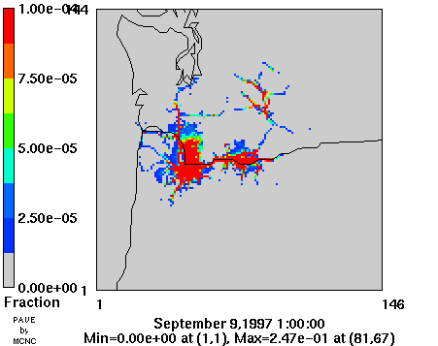
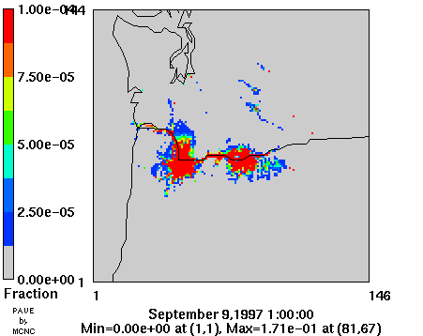
a
b

Figure A1. Fractional source contributions of an (a) inert pollutant (b) first order reactive pollutant on the receptor concentrations at Wishram on September 10, 1997.

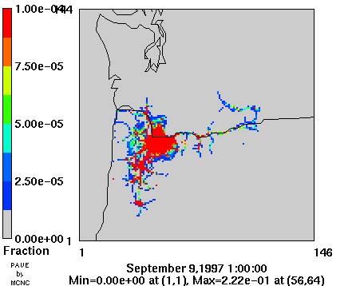
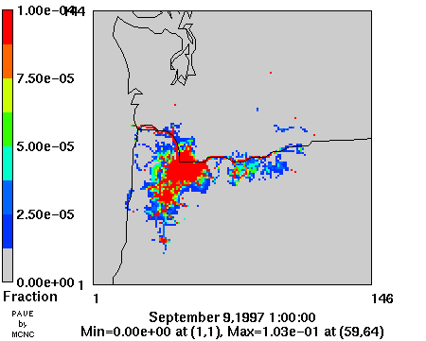
a
b

Figure A2. Fractional source contributions of an (a) inert pollutant (b) first order reactive pollutant on the receptor concentrations at Mt. Zion on September 10, 1997.

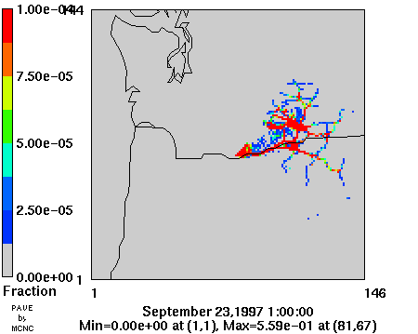
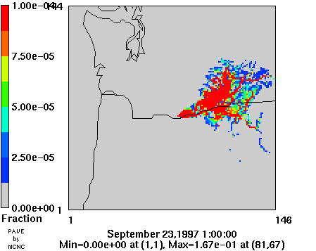
a
b

Figure A3. Fractional source contributions of an (a) inert pollutant (b) first order reactive pollutant on the receptor concentrations at Wishram on September 24, 1997.

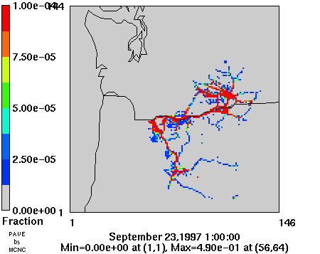
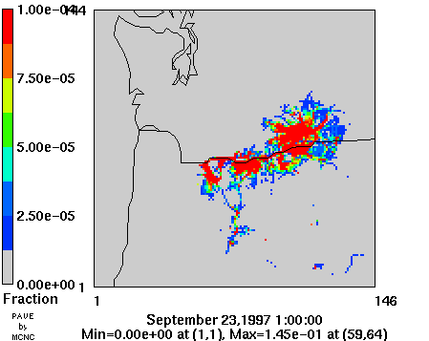
a
b

Figure A4. Fractional source contributions of an (a) inert pollutant (b) first order reactive pollutant on the receptor concentrations at Mt. Zion on September 24, 1997.

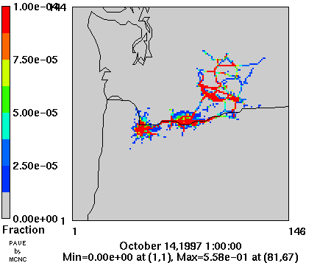
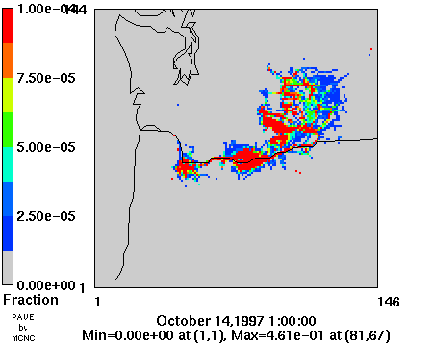
a
b

Figure A5. Fractional source contributions of an (a) inert pollutant (b) first order reactive pollutant on the receptor concentrations at Wishram on October 15, 1997.

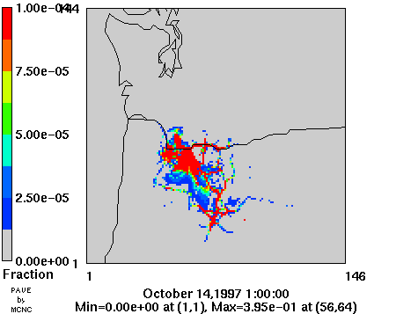
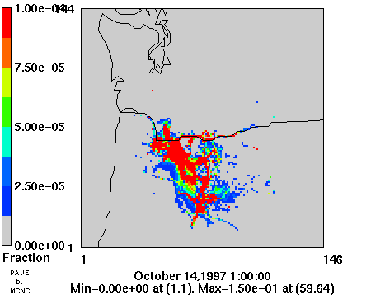
a
b

Figure A6. Fractional source contributions of an (a) inert pollutant (b) first order reactive pollutant on the receptor concentrations at Mt. Zion on October 15, 1997.

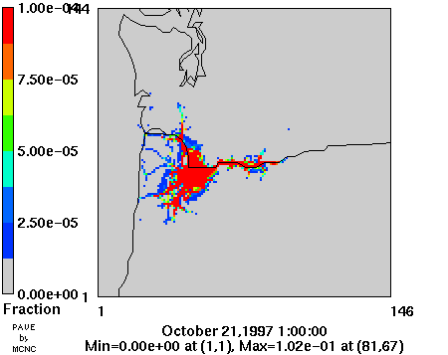
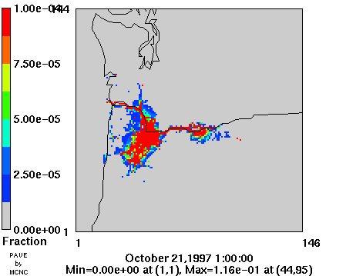
a
b

Figure A7. Fractional source contributions of an (a) inert pollutant (b) first order reactive pollutant on the receptor concentrations at Wishram on October 22, 1997.

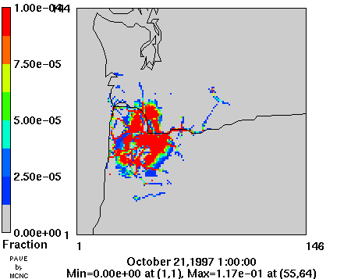
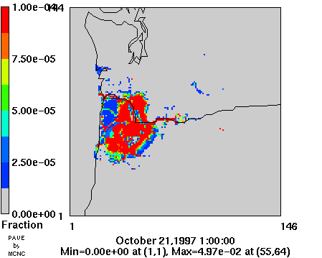
a
b

Figure A8. Fractional source contributions of an (a) inert pollutant (b) first order reactive pollutant on the receptor concentrations at Mt. Zion on October 22, 1997.

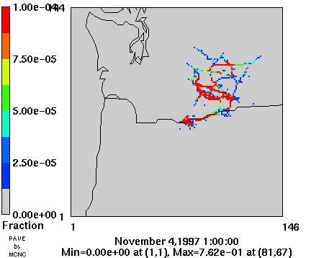
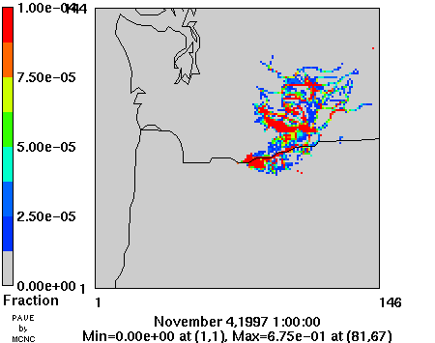
a
b

Figure A9. Fractional source contributions of an (a) inert pollutant (b) first order reactive pollutant on the receptor concentrations at Wishram on November 5, 1997.

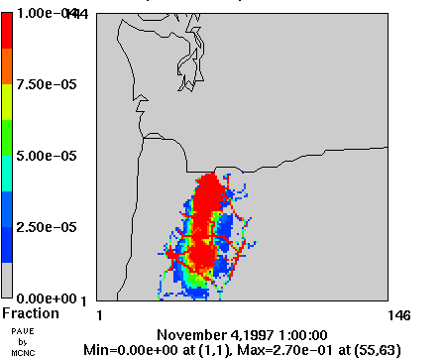
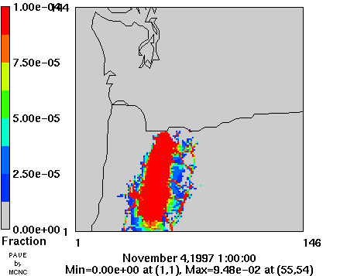
a
b

Figure A10. Fractional source contributions of an (a) inert pollutant (b) first order reactive pollutant on the receptor concentrations at Mt. Zion on November 5, 1997.

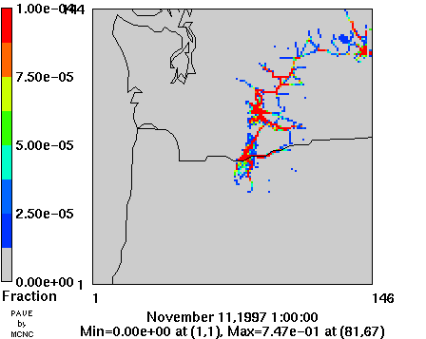
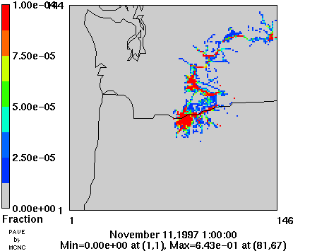
a
b

Figure A11. Fractional source contributions of an (a) inert pollutant (b) first order reactive pollutant on the receptor concentrations at Wishram on November 12, 1997.

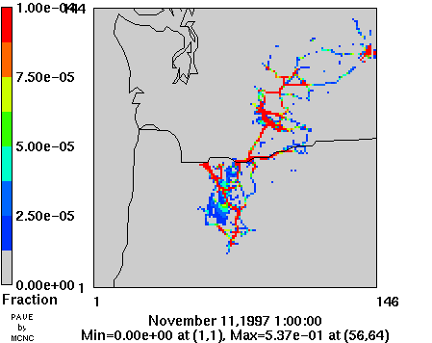
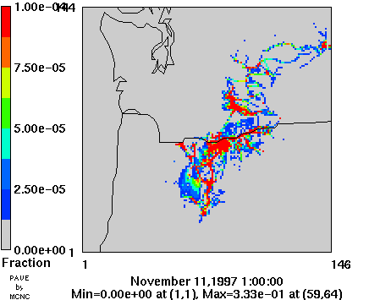
a
b

Figure A12. Fractional source contributions of an (a) inert pollutant (b) first order reactive pollutant on the receptor concentrations at Mt. Zion on November 12, 1997.

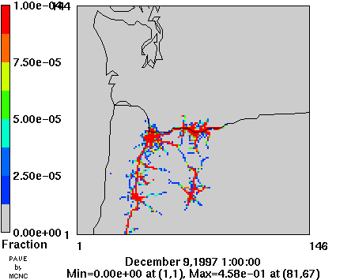
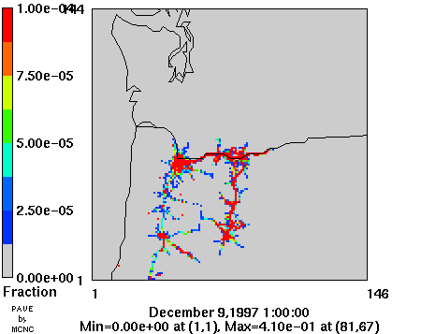
a
b

Figure A13. Fractional source contributions of an (a) inert pollutant (b) first order reactive pollutant on the receptor concentrations at Wishram on December 10, 1997.

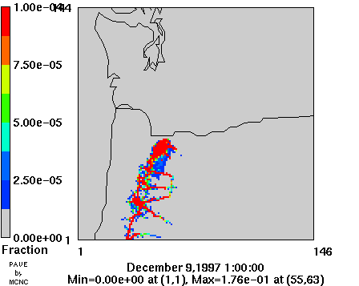
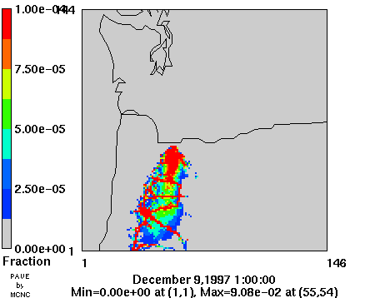
a
b

Figure A14. Fractional source contributions of an (a) inert pollutant (b) first order reactive pollutant on the receptor concentrations at Mt. Zion on December 10, 1997.

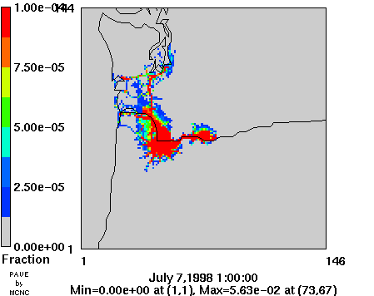
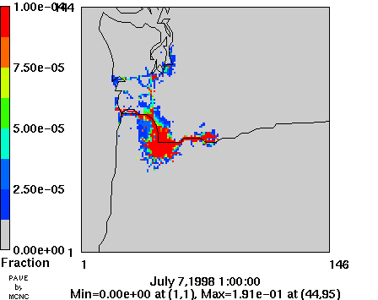
a
b

Figure A15. Fractional source contributions of an (a) inert pollutant (b) first order reactive pollutant on the receptor concentrations at Wishram on July 8, 1998.

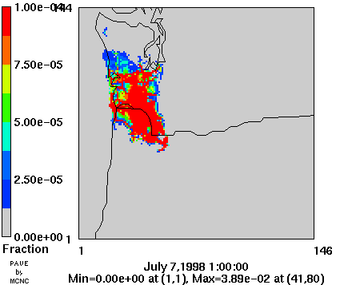
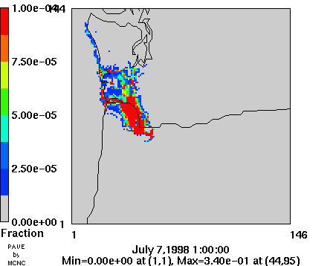
a
b

Figure A16. Fractional source contributions of an (a) inert pollutant (b) first order reactive pollutant on the receptor concentrations at Mt. Zion on July 8, 1998.

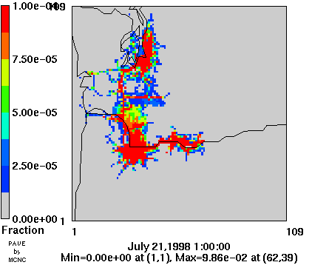
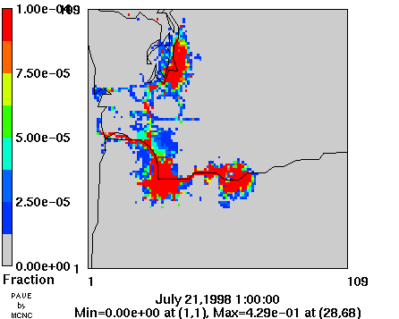
a
b

Figure A17. Fractional source contributions of an (a) inert pollutant (b) first order reactive pollutant on the receptor concentrations at Wishram on July 22, 1998.

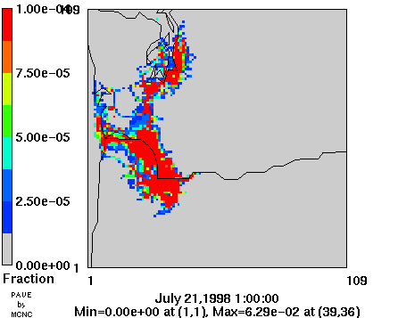
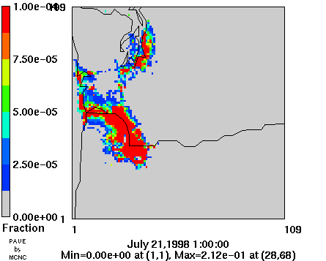
a
b

Figure A18. Fractional source contributions of an (a) inert pollutant (b) first order reactive pollutant on the receptor concentrations at Mt. Zion on July 22, 1998.

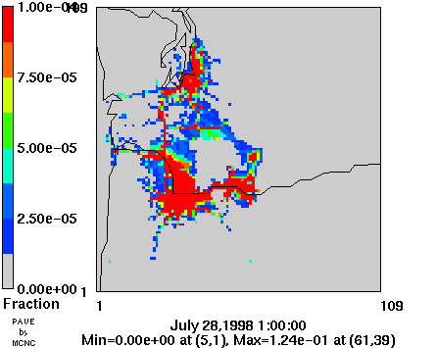
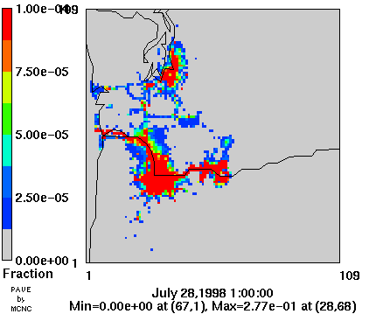
a
b

Figure A19. Fractional source contributions of an (a) inert pollutant (b) first order reactive pollutant on the receptor concentrations at Wishram on July 29, 1998.

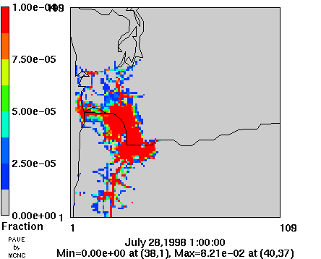
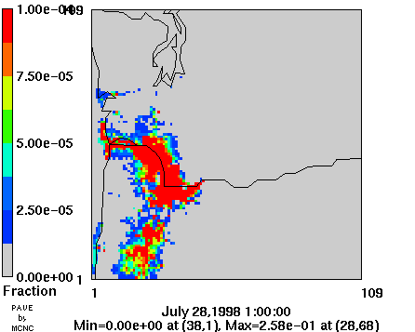
a
b

Figure A20. Fractional source contributions of an (a) inert pollutant (b) first order reactive pollutant on the receptor concentrations at Mt. Zion on July 29, 1998.

